1. Created a Project name GLTraining

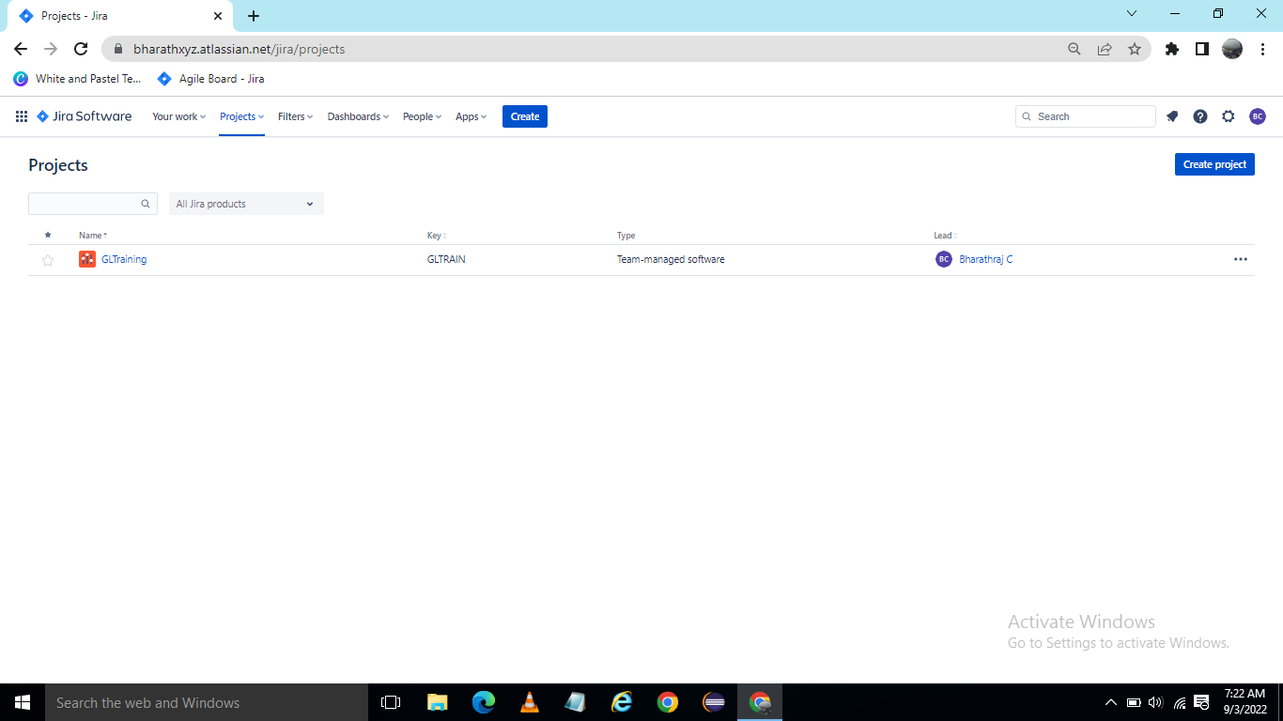

1. Created Epic for ATM Card Access   
   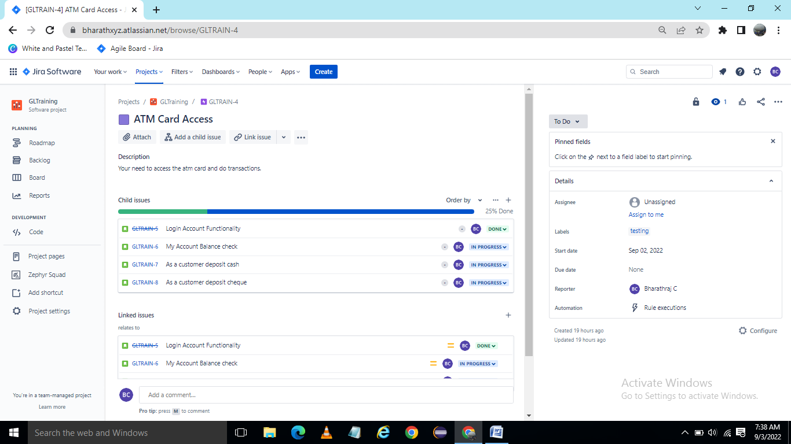
2. Created User Story for Login Access functionality  
     
   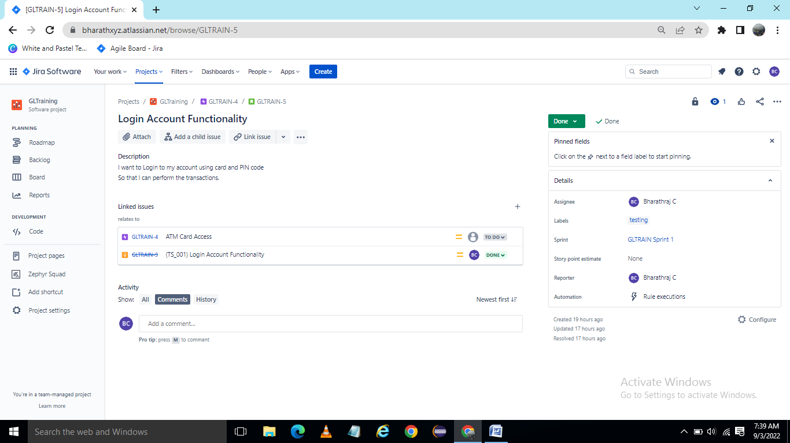
3. In board GLTrain Sprint1 Create Epic, User Story, and Bug

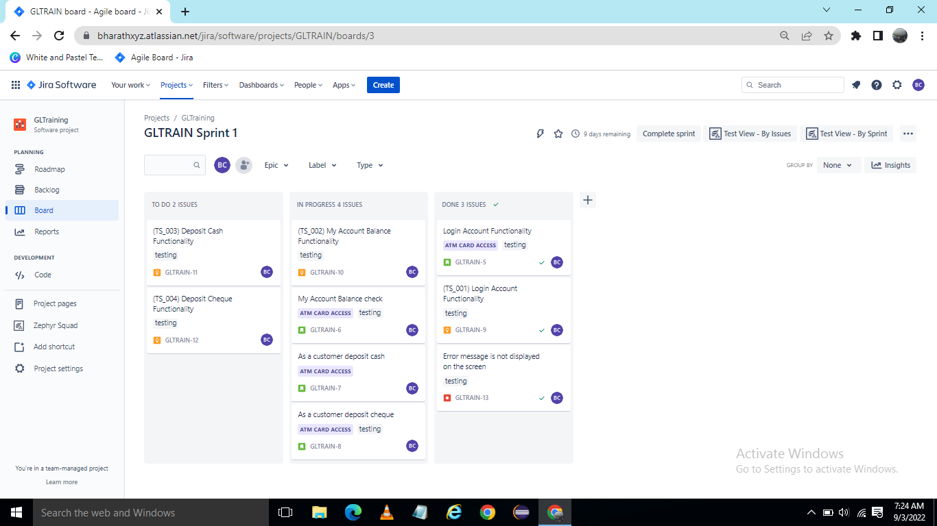

1. Create Test Cases by using Zephry  
     
   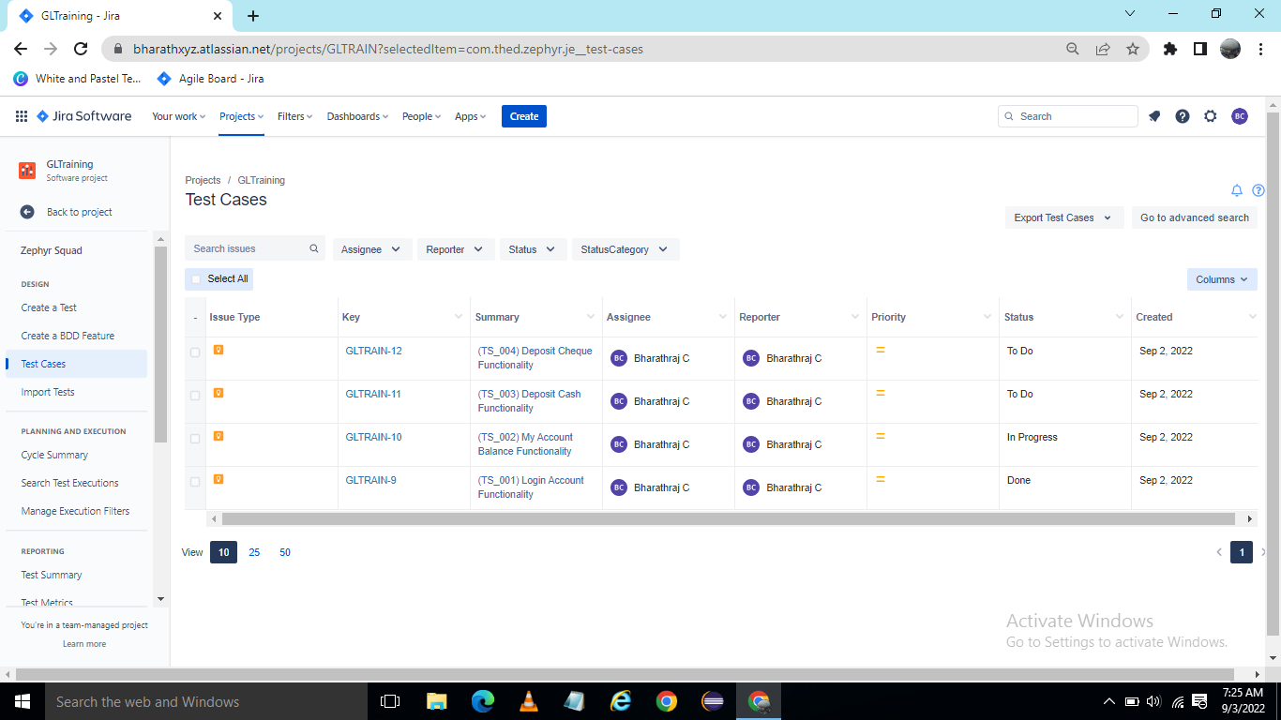
2. Write the Test cases for Login functionality  
     
   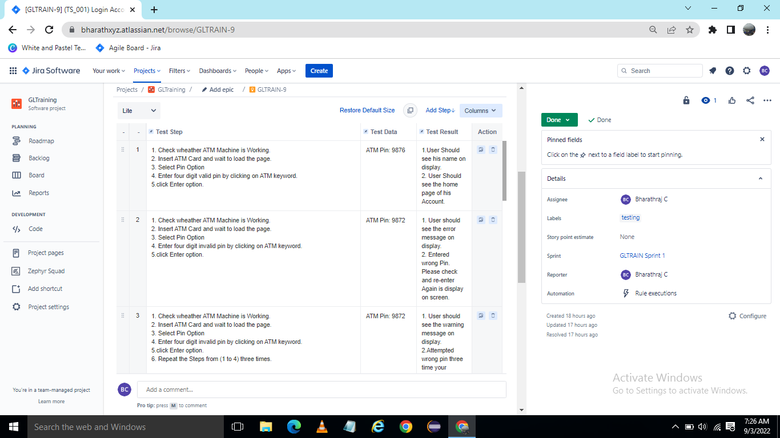
3. Test Cases Execution

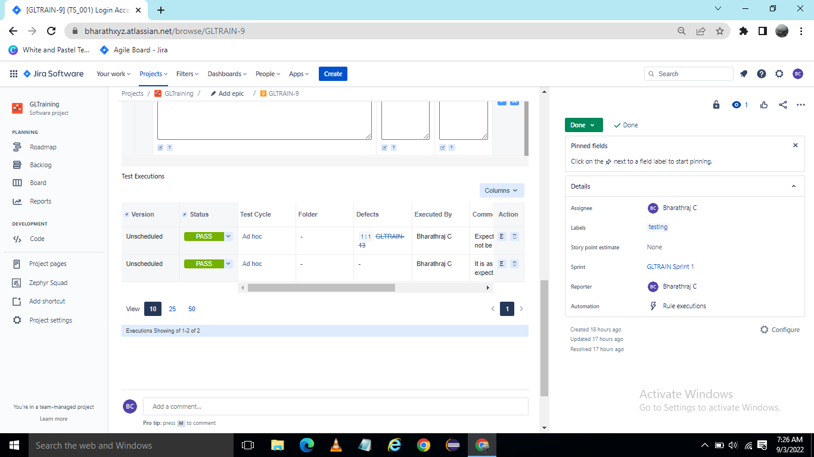

1. Create Bug

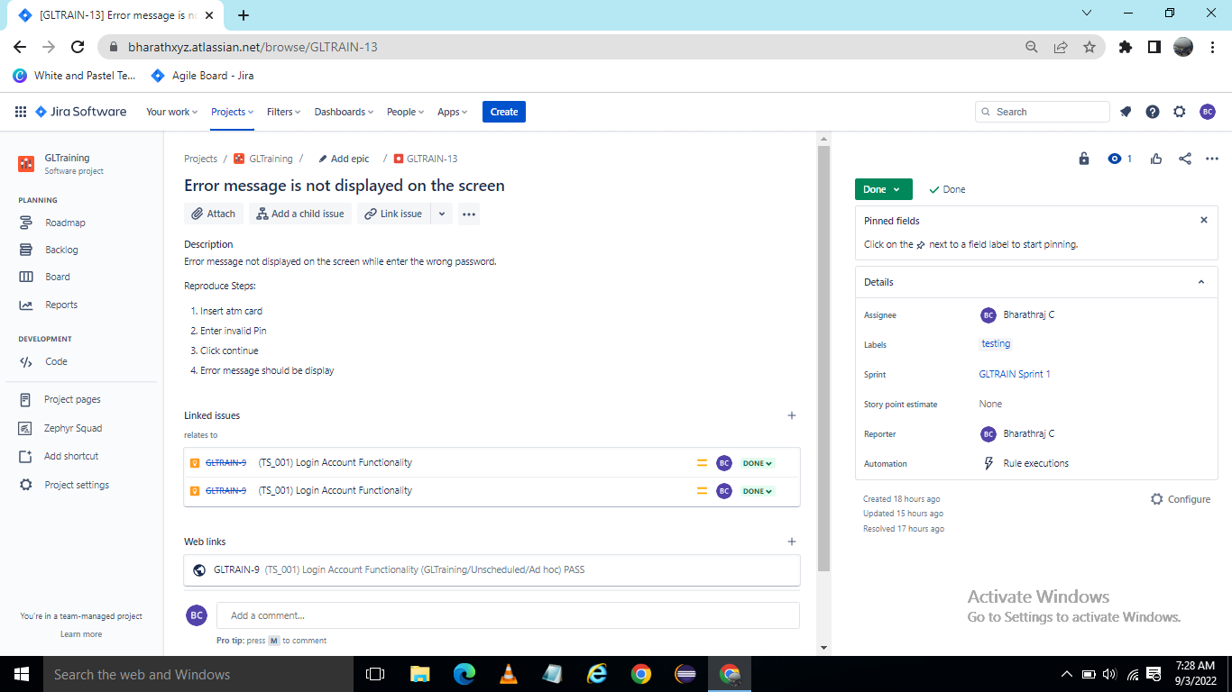

1. Login functionality User Story is done  
   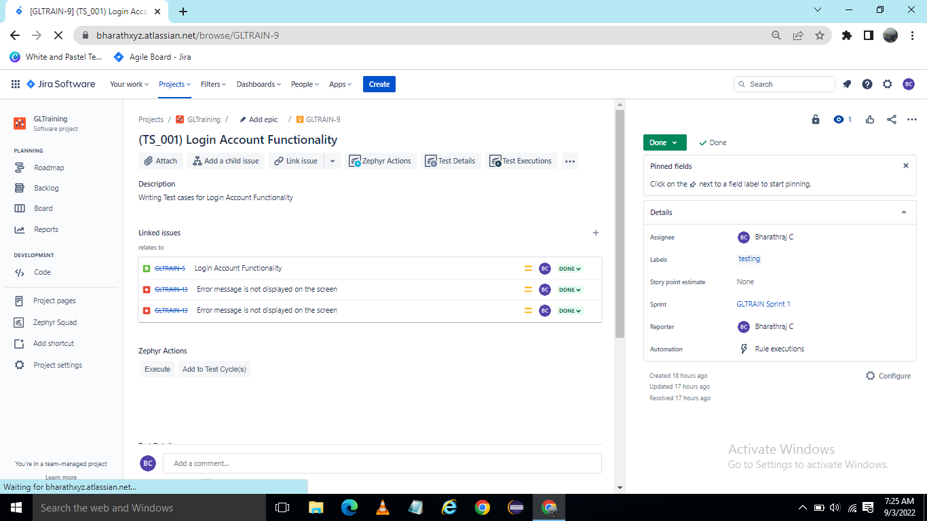
2. Backlog  
     
   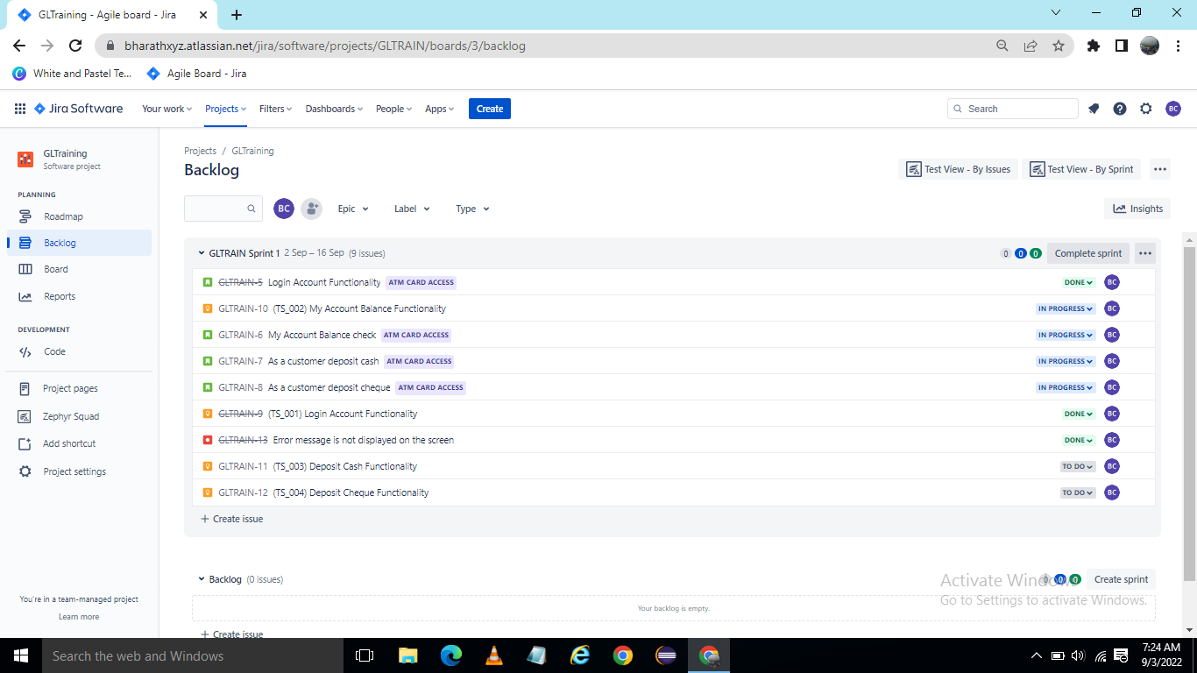
3. Roadmap  
     
   